Chapter 3

Development Environment Setup

Introduction

In this chapter, we will guide you through configuring your development environment to ensure optimal results. Since .NET MAUI is primarily focused on cross-platform development, our main focus will be on setting up your development environment on the Windows operating system. We will also discuss the additional steps required for configuring your Android development environment, which is crucial for testing and deployment.

While we will include details for iOS development, please note that we will not cover it in detail. The setup process for iOS development involves additional steps and requires a macOS system, which is beyond the scope of this chapter. However, we will provide enough information to help you get started with iOS development if you choose to do so in the future. Let us get your development environment up and running smoothly.

Structure

In this chapter, we will discuss the following topics:

* Installation of visual studio IDE
* Testing the environment setup
* Debugging on Windows
* Debugging on Android Emulator
* Debugging on Android devices
* iOS device provisioning
* Pair to Mac for iOS development

Objectives

After reading this chapter, you will be able to:

* Setup your development environment
* Debug on Windows environment
* Test the app in Android Virtual and a physical device
* Test the app in iOS simulator or a device
* Learn to pair a Mac to your development environment in Windows for iOS development

Installation of visual studio IDE

Visual Studio is a comprehensive IDE, that provides all the tools for everything from writing and editing code to debugging, building, and deploying applications. Alongside these core functionalities, Visual Studio packs compilers, code completion tools, source control features, extensions, and many other features to cover every phase of software development. With Visual Studio, you can write high-quality code efficiently and collaboratively.

Before you begin the installation process, check the prerequisites provided in the documentation. For Visual Studio 2022, the detailed requirements are provided at <https://learn.microsoft.com/en-us/visualstudio/releases/2022/system-requirements>.

Visual Studio is available in three editions tailored to different user needs: Community, Professional, and Enterprise. The Community Edition offers a fully featured IDE for students, open-source projects, and individual developers at no cost, and we will use it for the projects covered in this book. If you are developing for commercial purposes, please ensure that you check the license terms and conditions and opt for the Professional or Enterprise editions as applicable.

In this chapter, the steps are demonstrated for installing Visual Studio 2022 Community Edition on a Windows 10 PC, which has an x64 processor, 8 GB of RAM, and 50 GB of Hard disk space. You will need administrator permissions on the machine as well.

As Visual Studio is a versatile tool for different kinds of applications, it provides you with a workload-based installer, which allows users to install only the components they need. Follow these steps:

1. You can download the latest version of the Visual Studio Community Edition installer from <https://visualstudio.microsoft.com/vs/community/>. Refer to the following figure for the webpage from where you can download Visual Studio Community Edition:

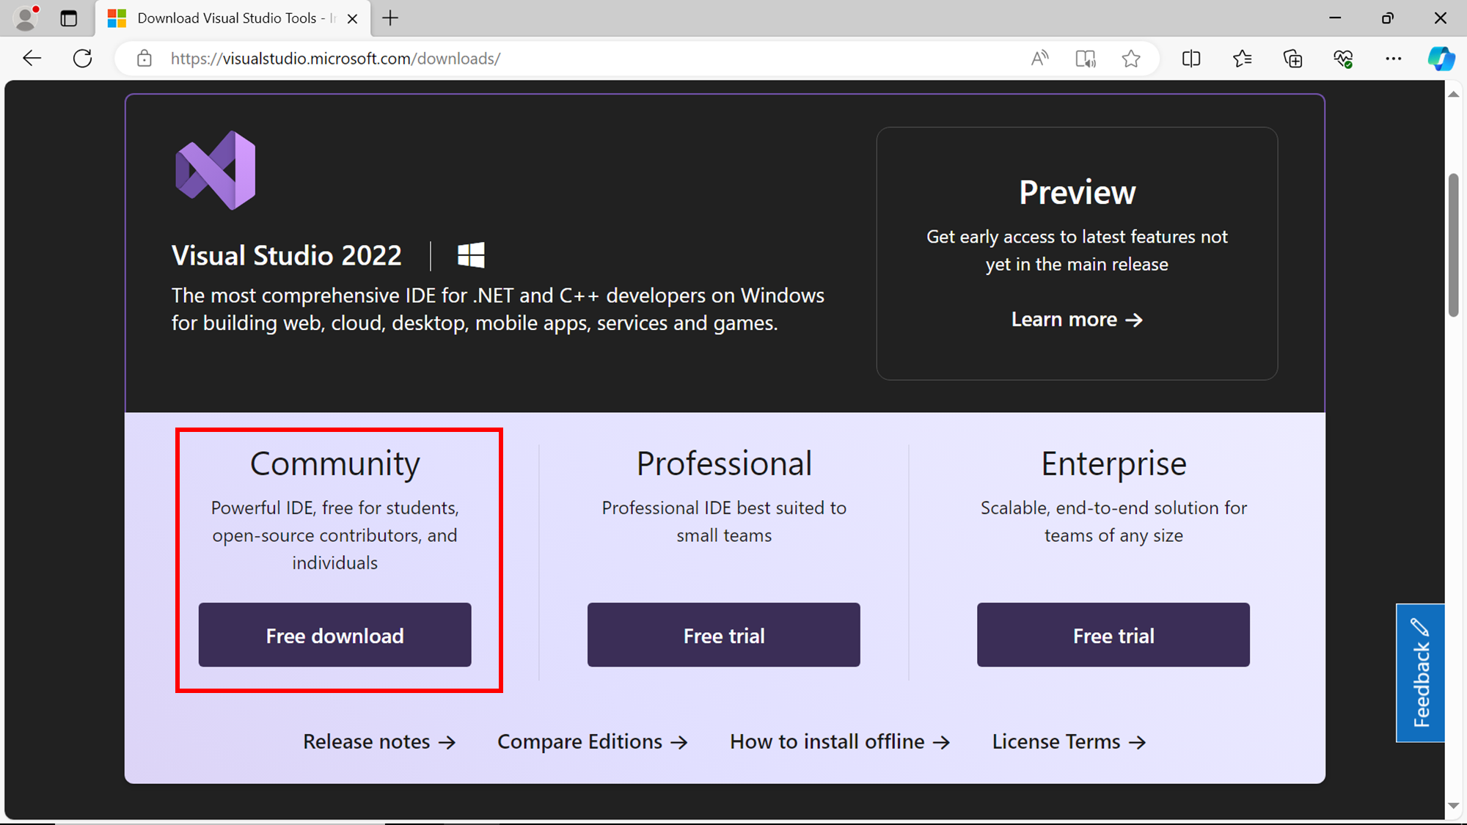

**Figure 3.1**:Download Visual Studio community edition

Unless you have changed the downloads folder path, when the download is complete, the setup file for installation will be saved to your **Downloads** folder, as shown in the following figure:

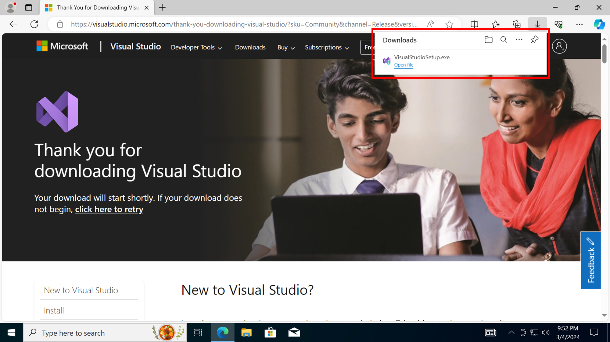

**Figure 3.2**:Check the Downloads folder for the setup file

1. After installing the Visual Studio installer, you can run it to customize your installation, as shown in the following figure:

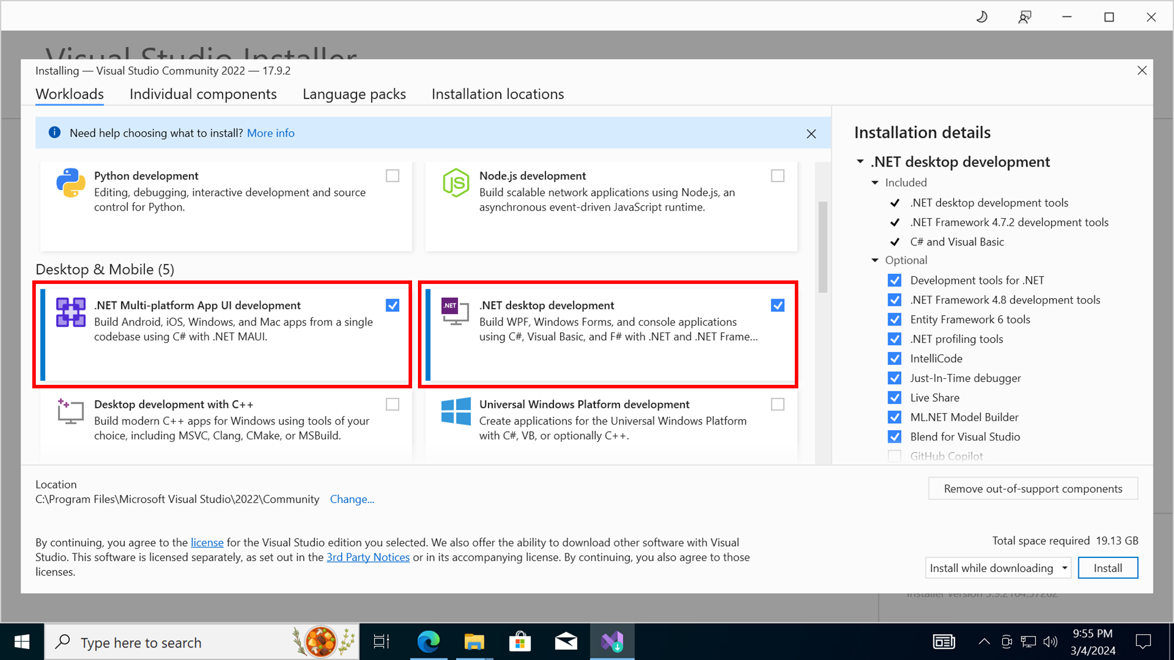

**Figure 3.3**:The Visual Studio installer

1. Choose the workloads indicated and the optional components which are selected by default and click on **Install**.
2. The installation process is fully automated and you can check the status screens for the progress of the installation. Refer to the following figure for the status message when installation is successfully completed:

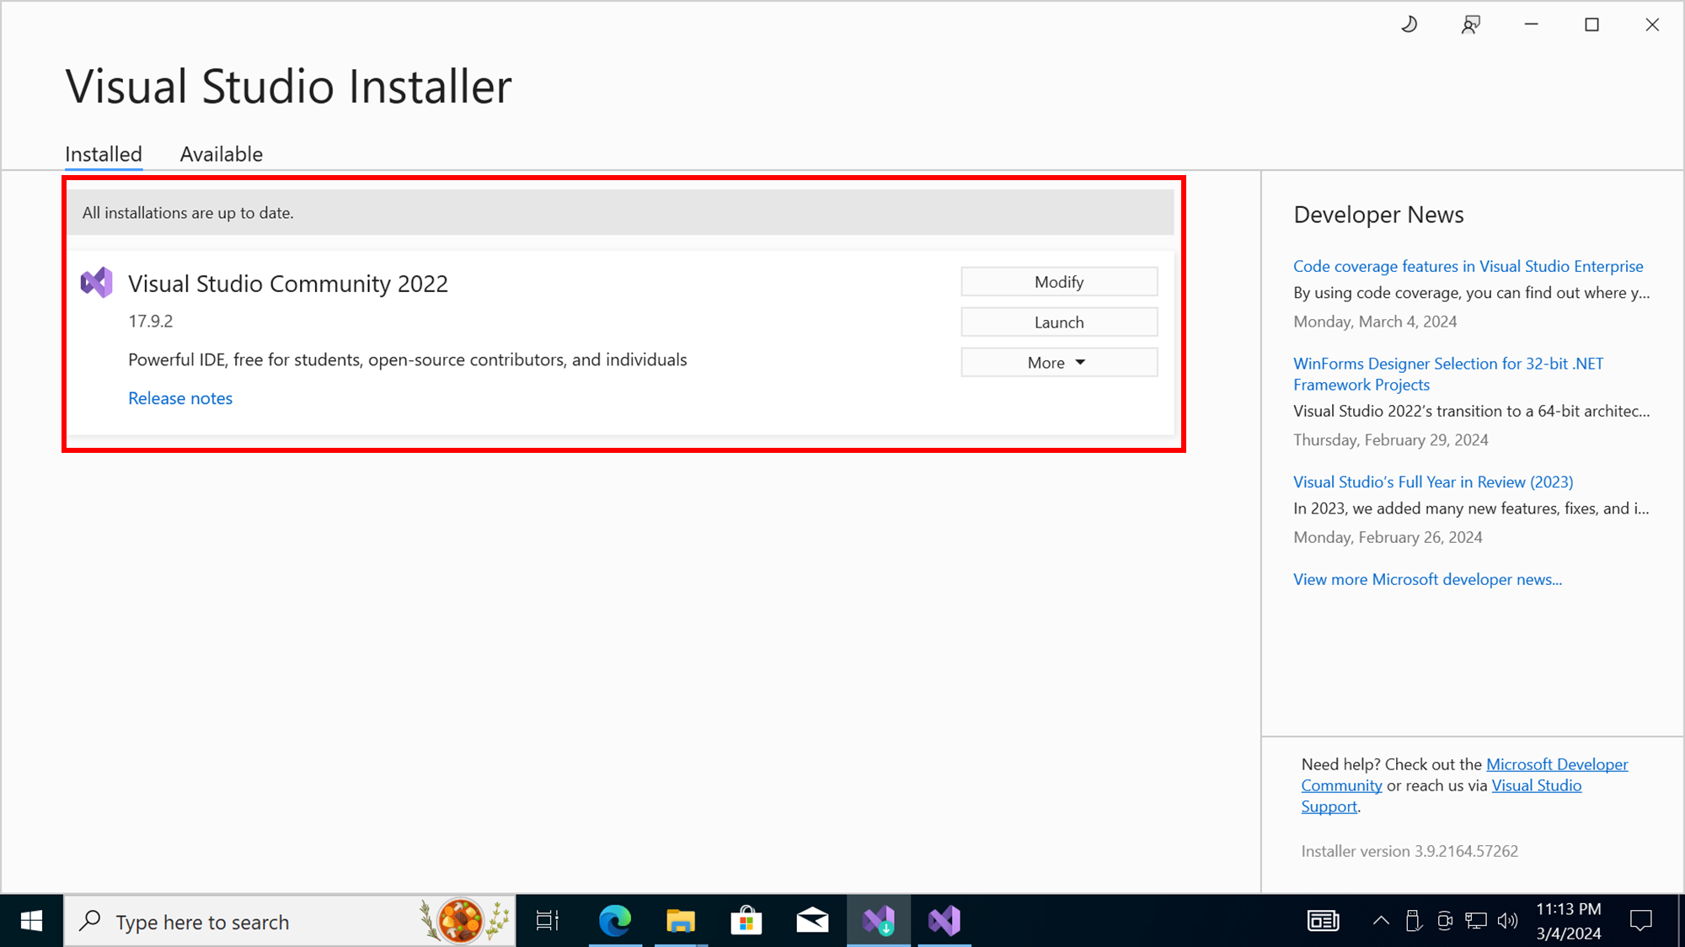

**Figure 3.4**:Completed status of Visual Studio installation

In case you have already installed Visual Studio IDE for other purposes, you need not uninstall it.

You can modify the existing installation and add the required workloads or components any time. You can also install multiple versions of Visual Studio side by side.

Testing the environment setup

Once your Visual Studio installation is completed, follow these steps:

1. Click the **Launch** button to start the Visual Studio IDE.
2. You can create a free account to preserve your personalized preferences across devices, but for the purpose of this chapter, you can skip the step for now. Refer to the following figure for an illustration of the sign up screen:

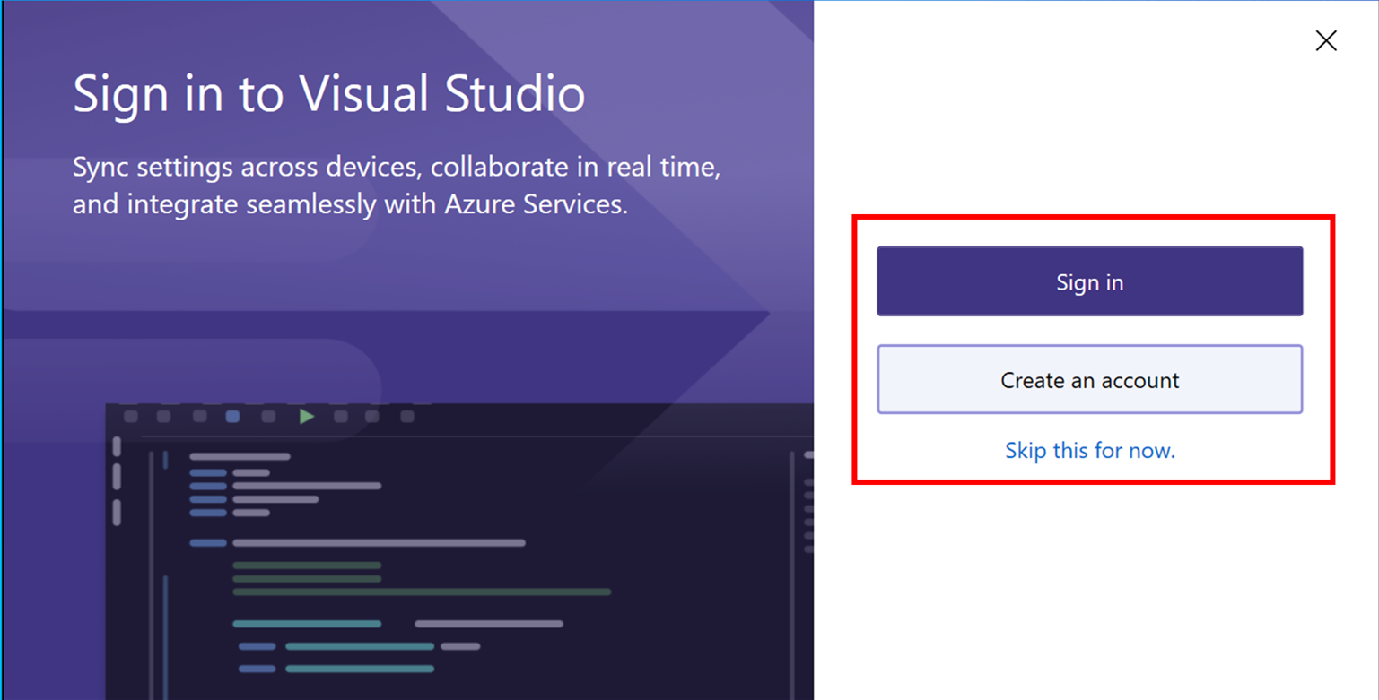

**Figure 3.5**:Sign-in screen

1. Assuming that you are a first-time user, it is always good to start with a simple C# Console application to get familiar with Visual Studio IDE.
2. In the start screen, select **Create a new project**. Refer to the following figure for the option to select the create a new project:

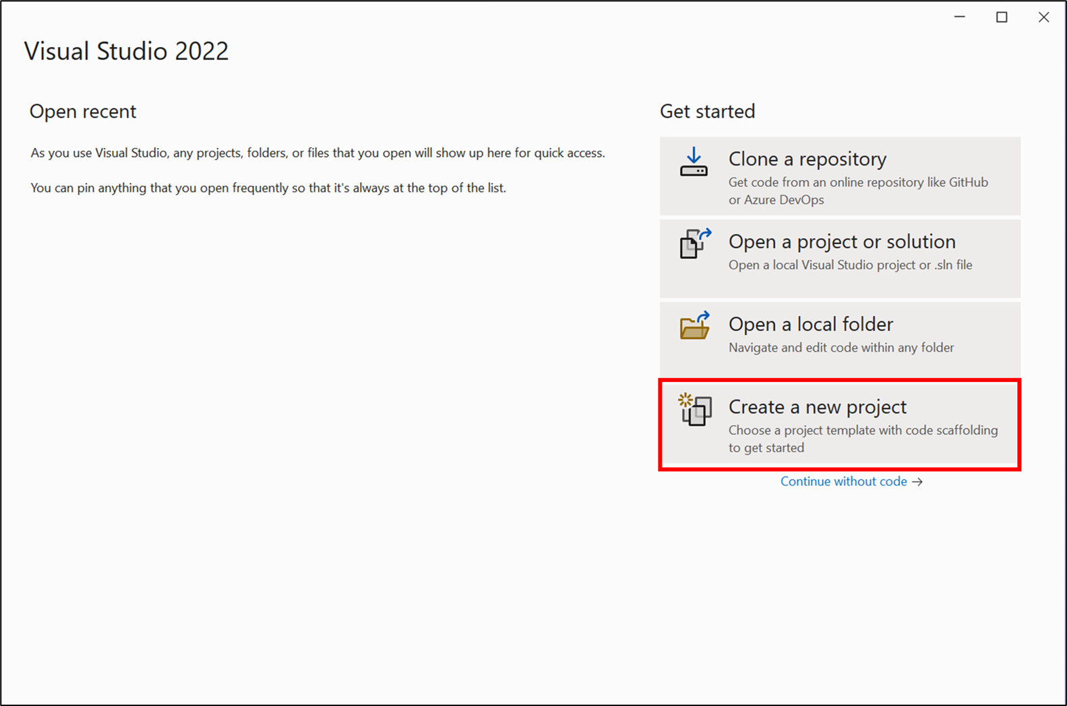

**Figure 3.6**: Creating a new project

1. You can scroll through the list of templates or use the template search box to type in Console application. Click on the **Console App** template as shown in the figure:

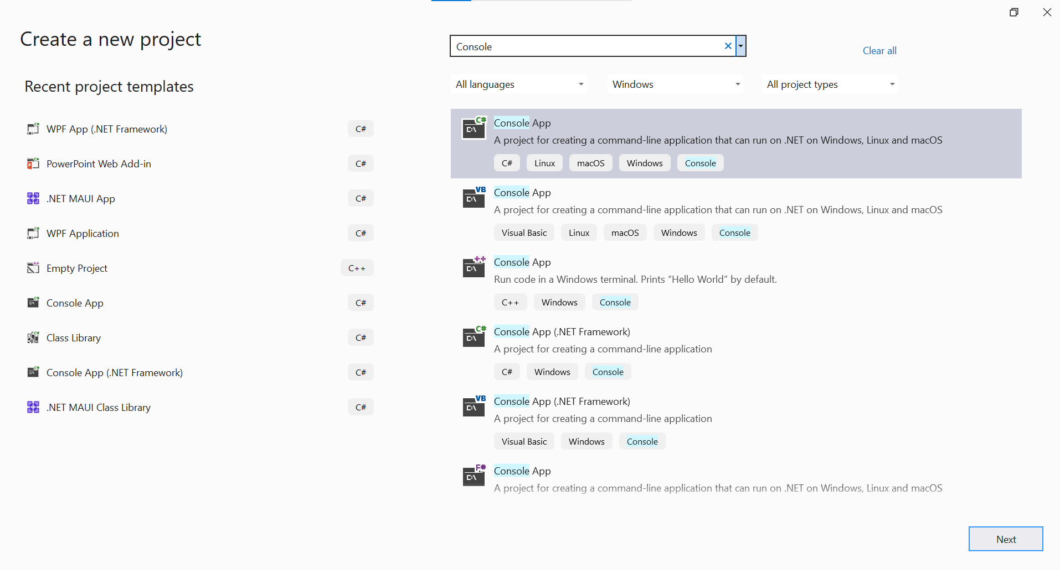

**Figure 3.7**: Selecting the Console App template

1. The programming language that we will be using in this book is C# and so ensure you select C# in the language drop-down menu. Refer to the following figure for the option to select the programming language:

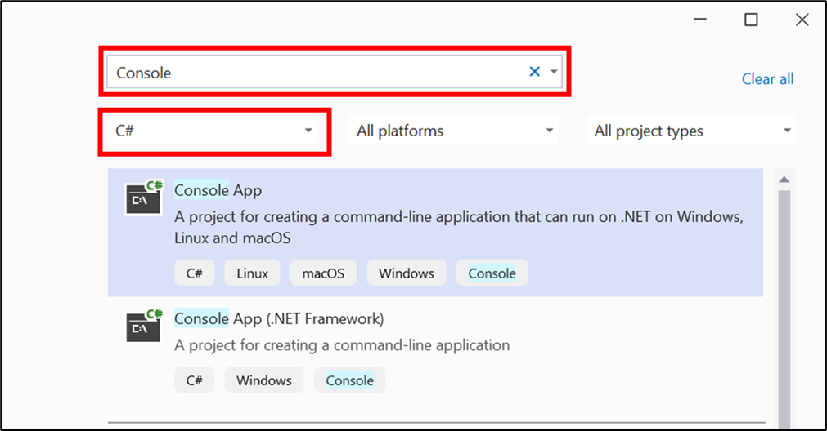

**Figure 3.8**: Selecting the programming language

1. Select the **Console App** template and click **Next**.
2. In the next screen, you will be able to configure your new project. Refer to the following figure:

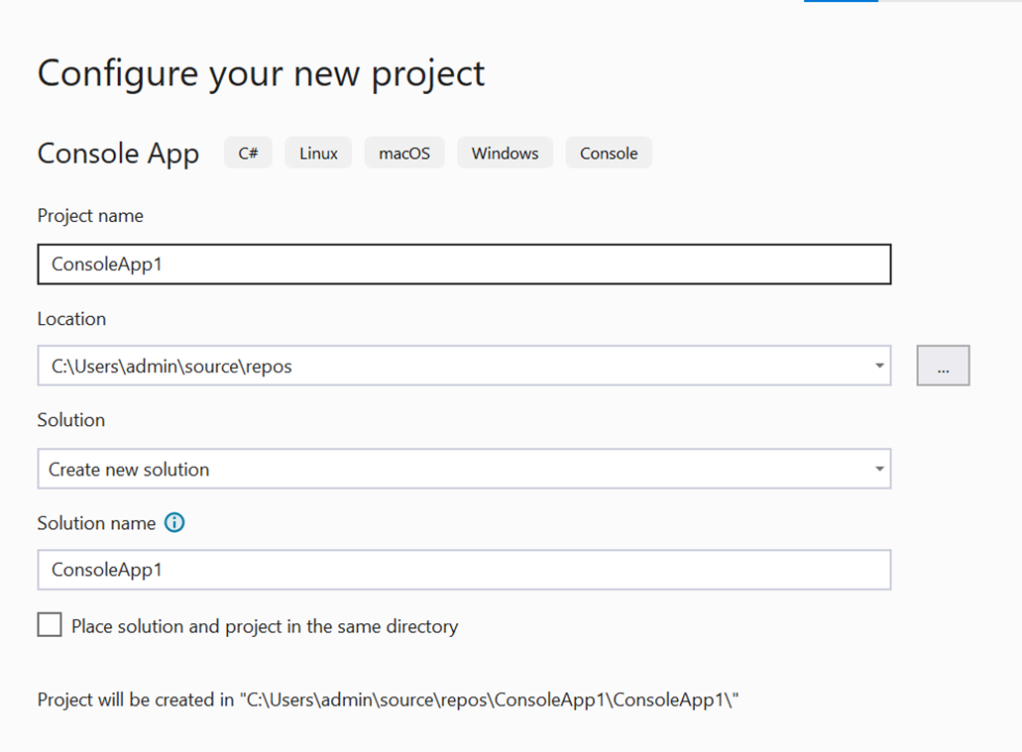

**Figure 3.9**:Configuring the new project

1. Provide a name for the project. It is advisable to use alphanumeric characters only without any space or special characters. Refer to the following figure for selecting the project name:

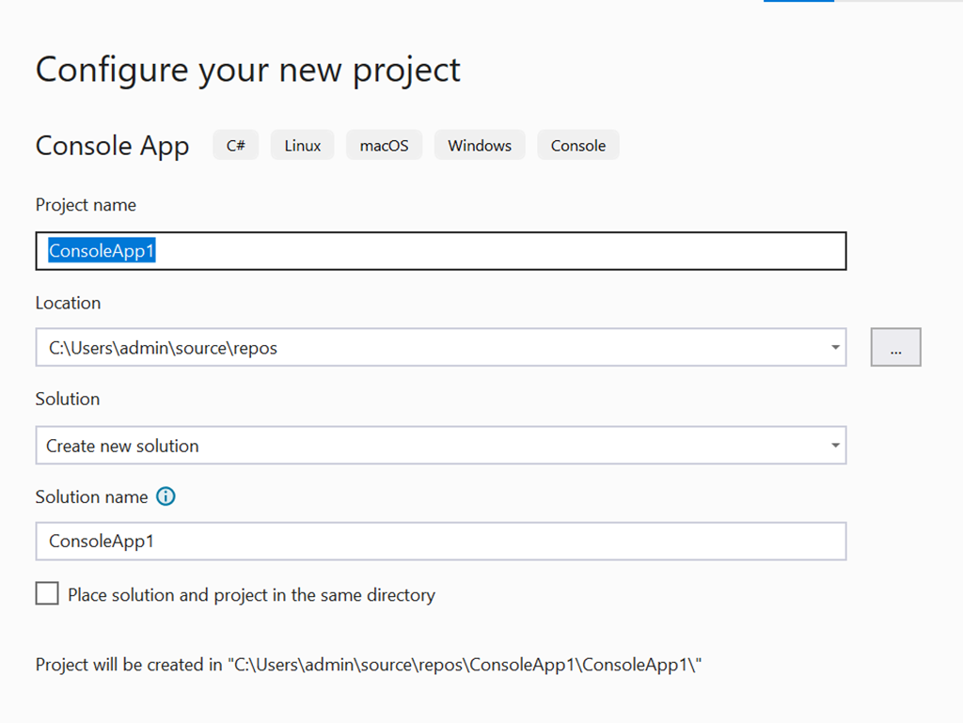

**Figure 3.10**:Selecting the project name

1. Choose the desired location. As you can see, by default, the project is saved it in the **\source\repos** folder under the logged in user’s profile. Refer to the following figure:

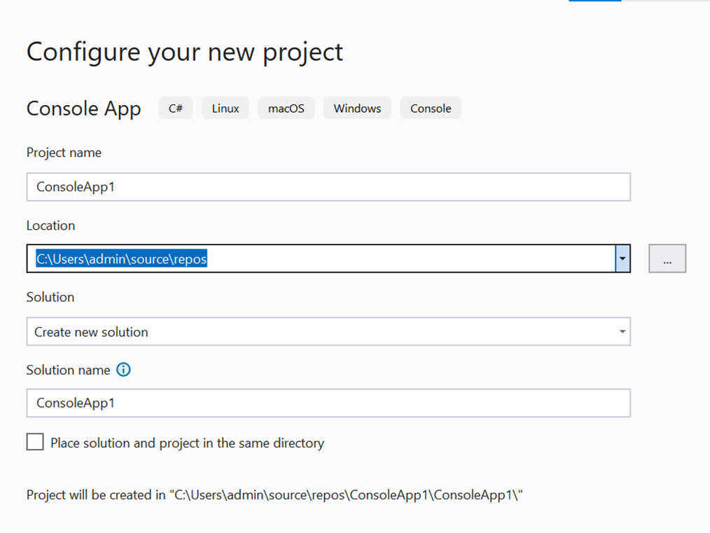

**Figure 3.11**:Selecting the location for the project files

1. A solution in Visual Studio is a container to hold multiple projects. You can choose a new solution or add the project to an existing location. We will choose to create a new solution, which will have the same name as that of the project by default. If desired, you can change it, but this is purely optional. Refer to the following figure:

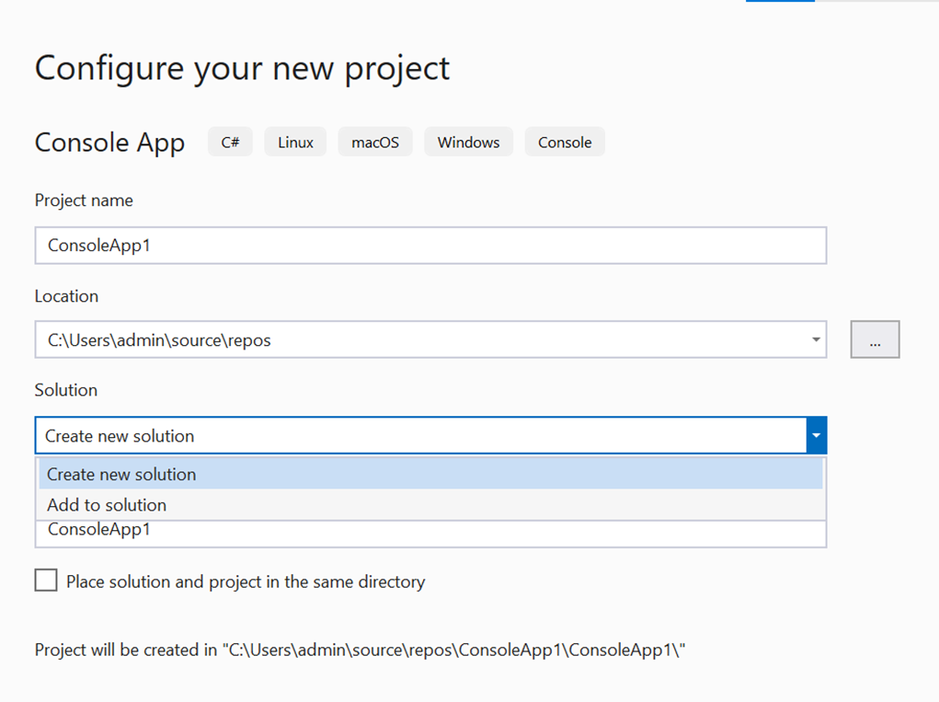

**Figure 3.12**: Configuring the solution

1. Ignore the option to place solution and project in the same directory and leave it at its default unchecked setting. Refer to the following figure to select the option to create a new solution:

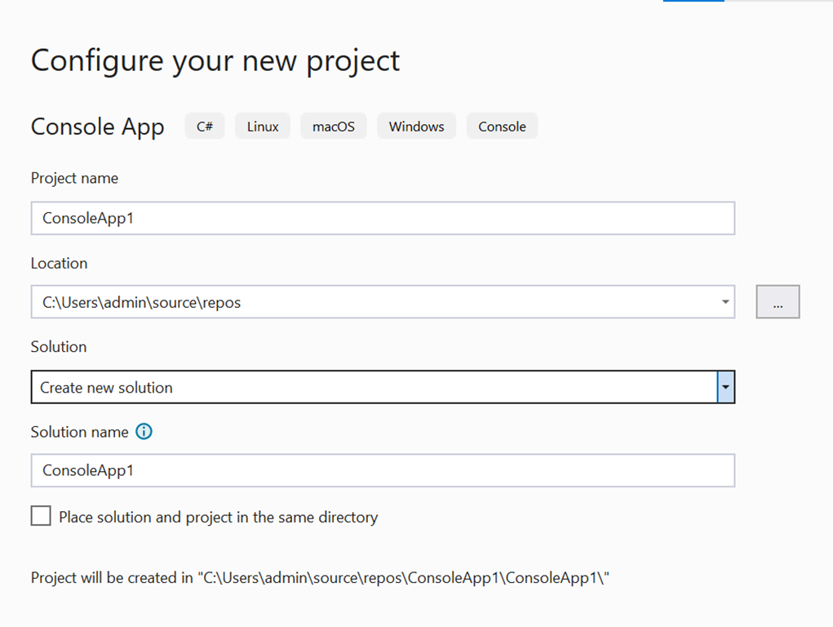

**Figure 3.13**: Creating a new solution

1. Click **Next**. Under **Additional information**, you can choose the **Framework** version that you want to target but leave it at the default setting for now. Refer to the following figure:

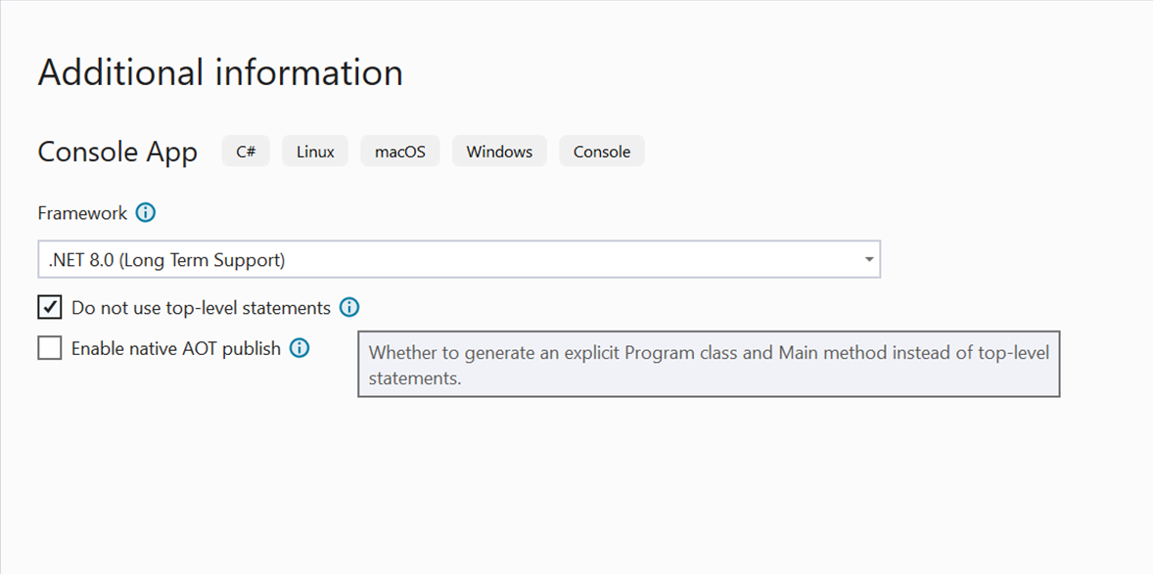

**Figure 3.14**: Configuring additional information for the project

1. Also check the option to avoid using top-level statements, which is a new feature introduced in a recent version of C# to directly write executable code without wrapping the code in a C# class or method. Click **Create**.
2. By default, a simple Console application is created for you. We will discuss C# in more detail in a subsequent chapter, but in this chapter, we will just focus on the basic features of the IDE and the development process to get you started.
3. The key sections of the IDE are highlighted in the following figure:

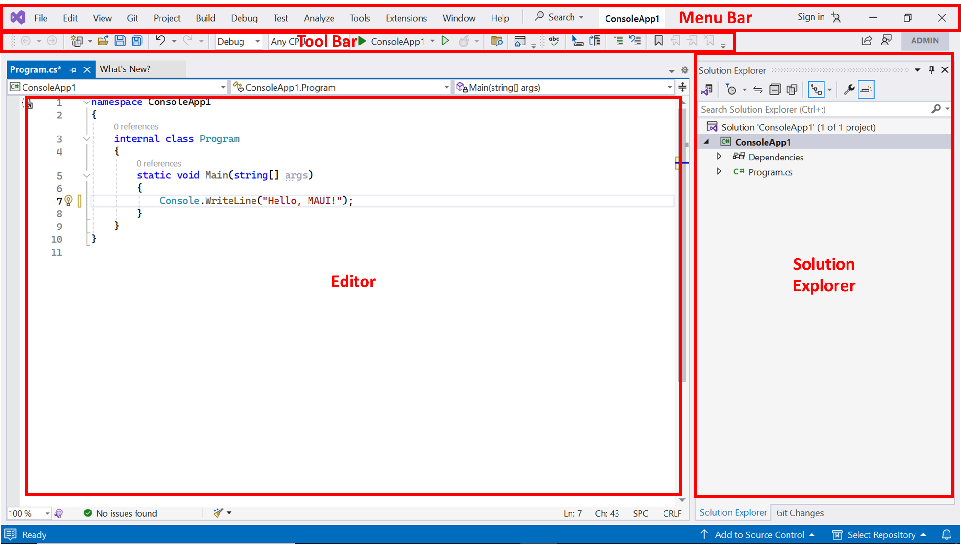

**Figure 3.15**: Visual Studio IDE Layout

1. In the **Solution Explorer**, you will find a **Program.cs** which contains the program.
2. Double-click the file to open it in the editor area to make any changes. For this example, we have just updated the string in line no. 7 to display a simple message to the user when the program is executed. Refer to the following figure:

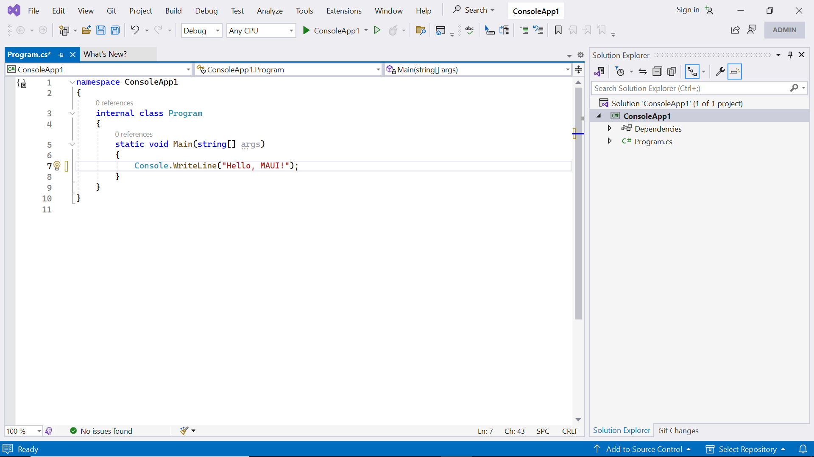

**Figure 3.16**:Editing in Visual Studio

1. After editing the program, it has to be compiled and then executed. Click on **Debug** | **Start Debugging** in the menu bar. An output pane will appear at the bottom of the editor to display the status of the compilation and execution process. Refer to the following figure:

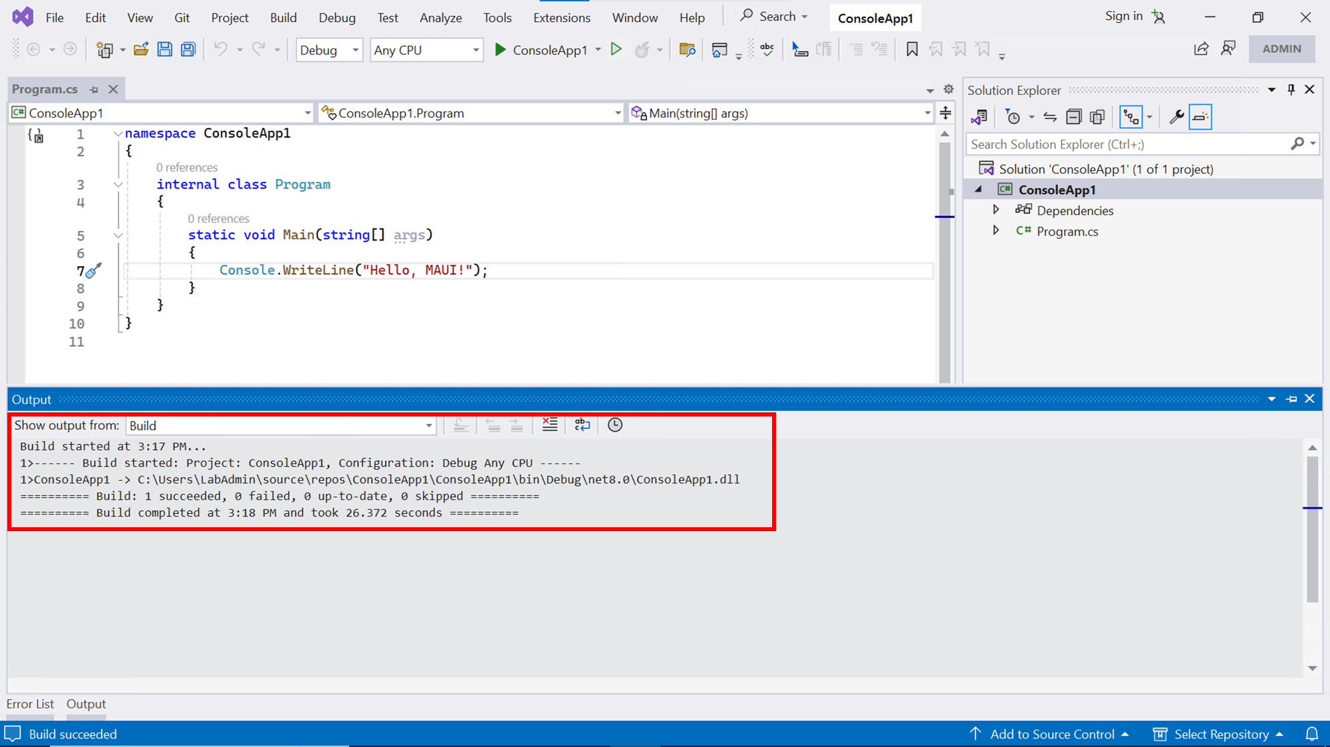

**Figure 3.17**: Building the program

1. If the program has no errors, it will be successfully compiled and you should be able to see the output of the program in a console window:

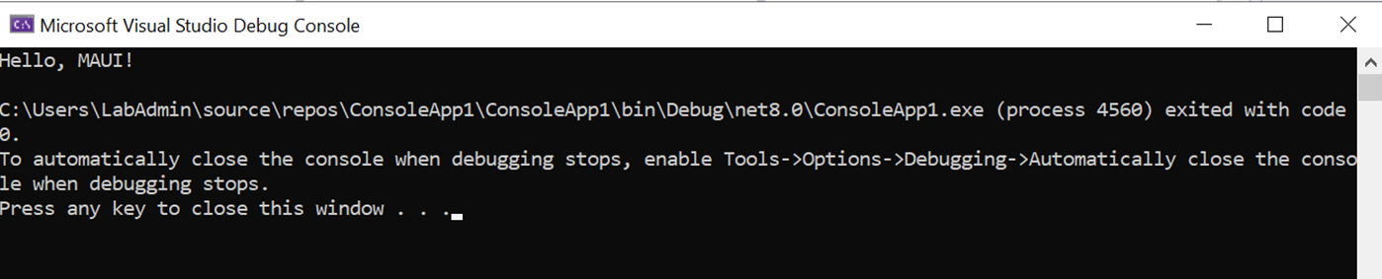

**Figure 3.18**: The output of the program

1. In case there is an error in the program, as shown in the following figure where we intentionally removed the semi-colon at the end of line no. *7*, the compiler will display an error during the compilation process, and the program will not be executed:

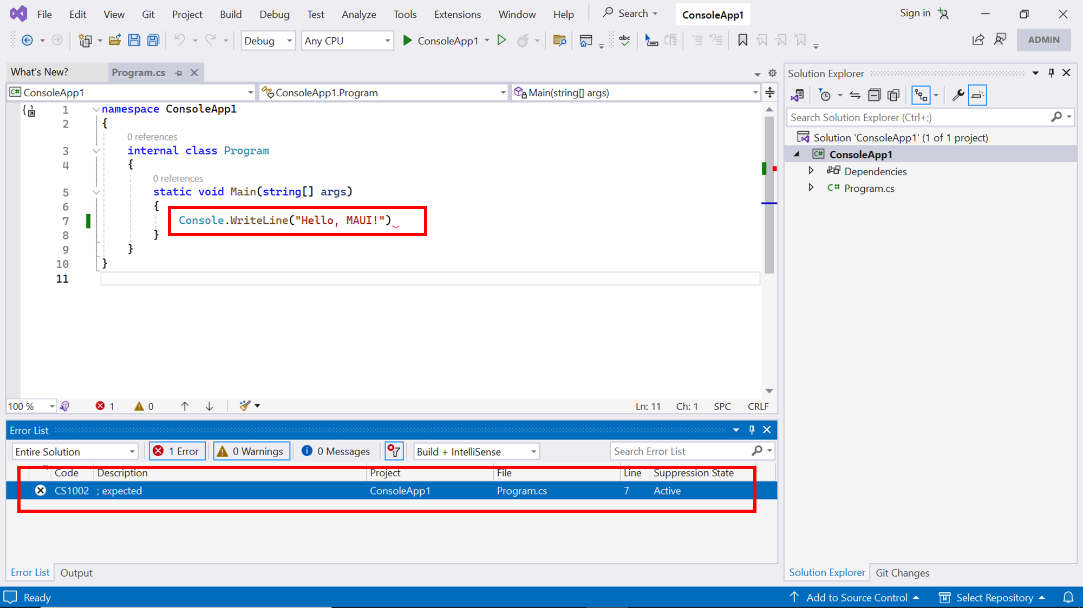

**Figure 3.19**:Viewing errors in Visual Studio IDE

Debugging on Windows

Now, that you are comfortable with the core functionalities of Visual Studio, it is time to write a simple NET MAUI App and test it on a Windows machine. Follow these steps for debugging on Windows:

1. From the menu bar, select **New Project**.
2. Search for MAUI and select **.NET MAUI App**:

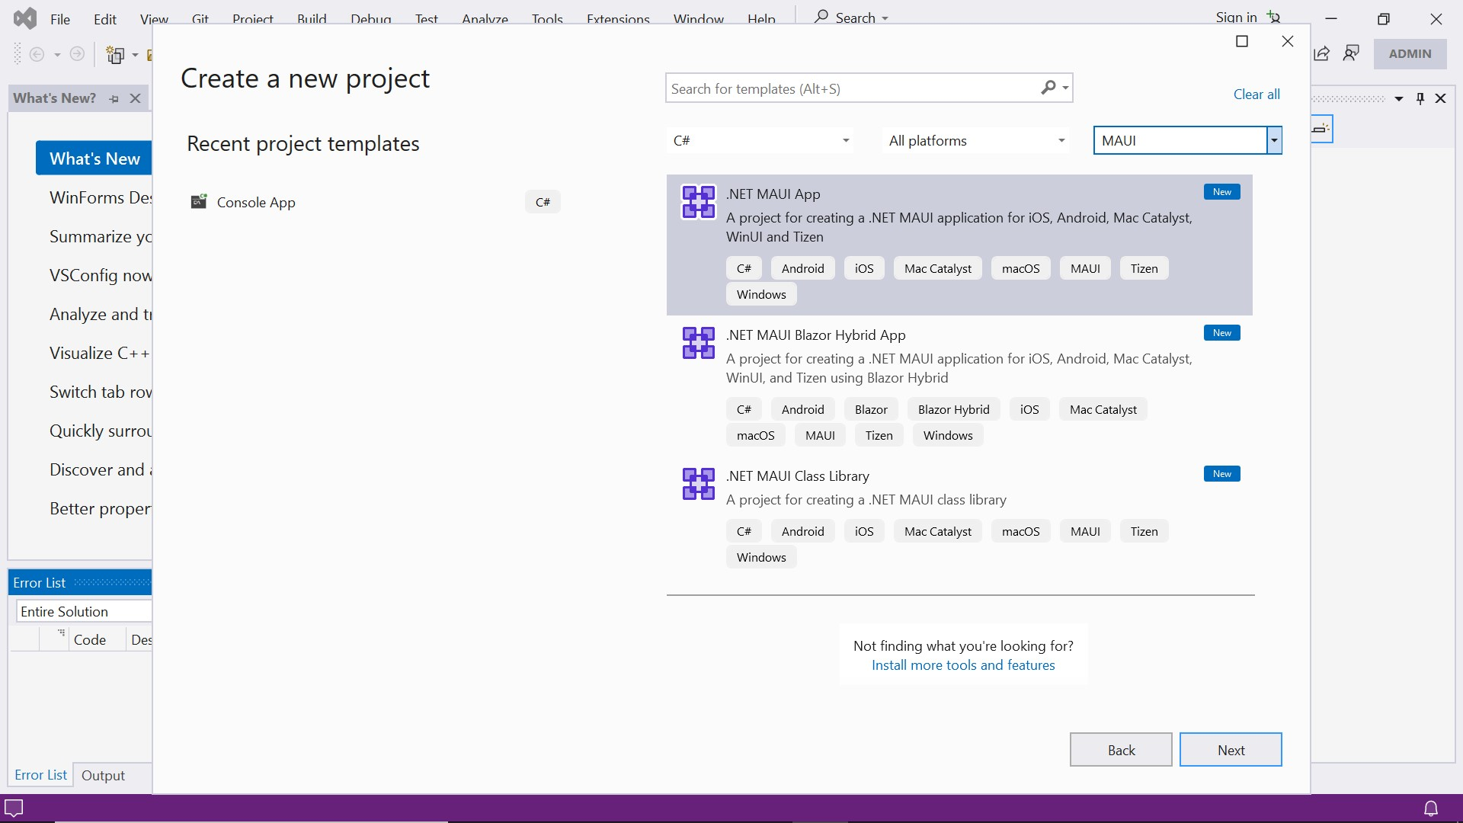

**Figure 3.20**: Selecting the .NET MAUI App Template

1. Enter a suitable **Project Name** and choose the **Target Framework** version just like you did for the console application and create the project:

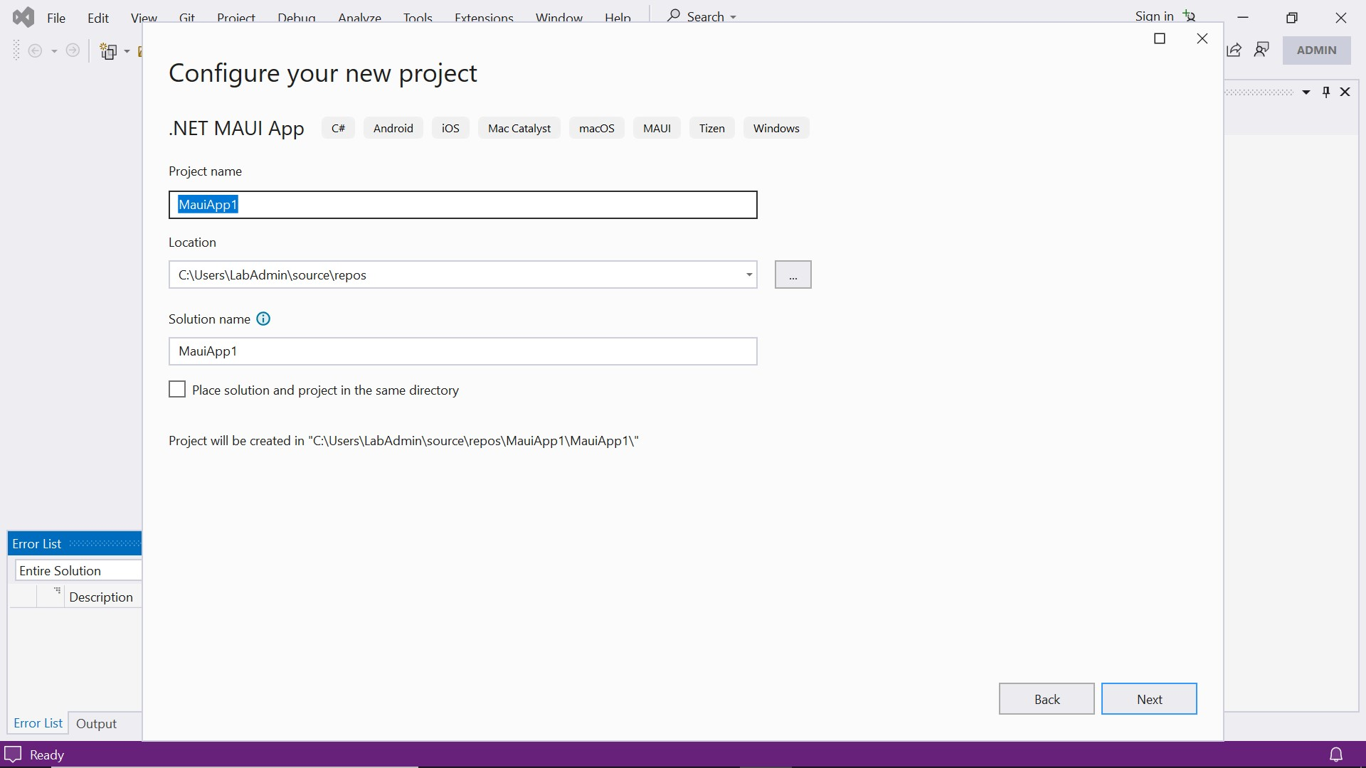

**Figure 3.21**: Configuring the .NET MAUI project

1. A boilerplate solution is already created for you so you can directly execute this application:

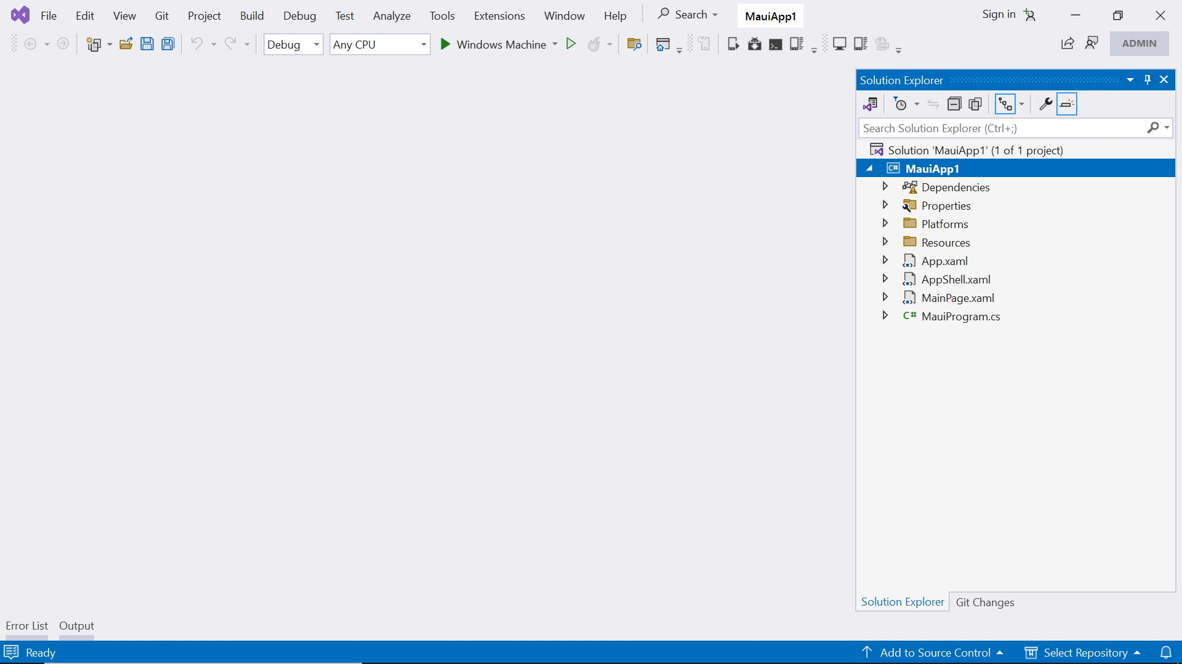

**Figure 3.22**: The default .NET MAUI project structure

1. From the toolbar click on the button which displays **Windows Machine** to start debugging on Windows device. Refer to the following figure:

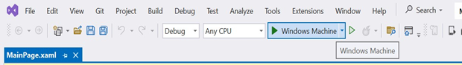

**Figure 3.23**: Debugging on Windows Machine

1. If this is the first time you are trying to run a .NET MAUI application on your Windows PC, you will see the dialog as shown in the below figure, prompting you to enable Developer Mode for Windows.

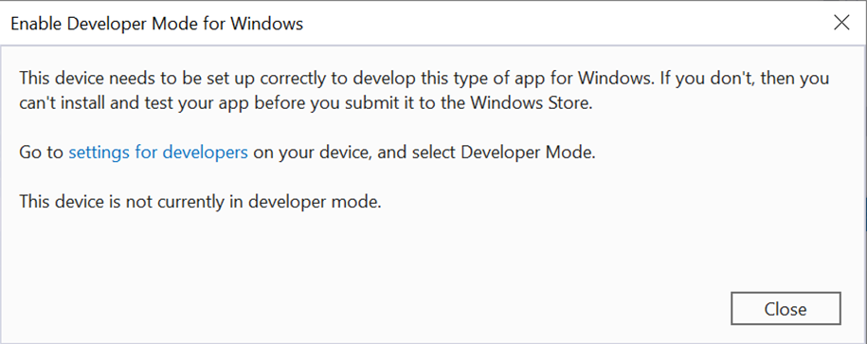

**Figure 3.24**:Dialog to enable Developer Mode for Windows

1. To enable **Developer Mode**, you can either click on the hyperlink provided in the dialog or alternatively access **Developer** settings from the **Settings** menu:

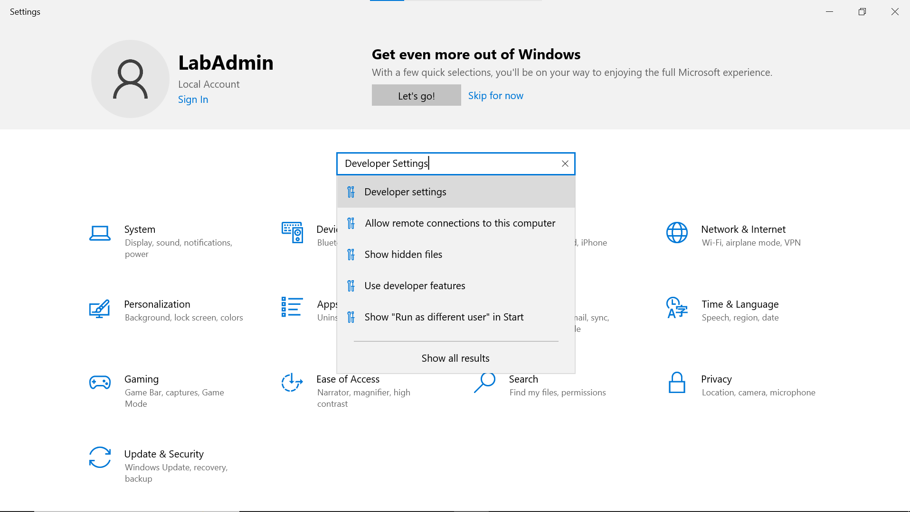

**Figure 3.25**:Searching for Developer Settings

1. In the menu **For developers**, enable the option under **Developer Mode** to **Install apps from any source, including loose files**:

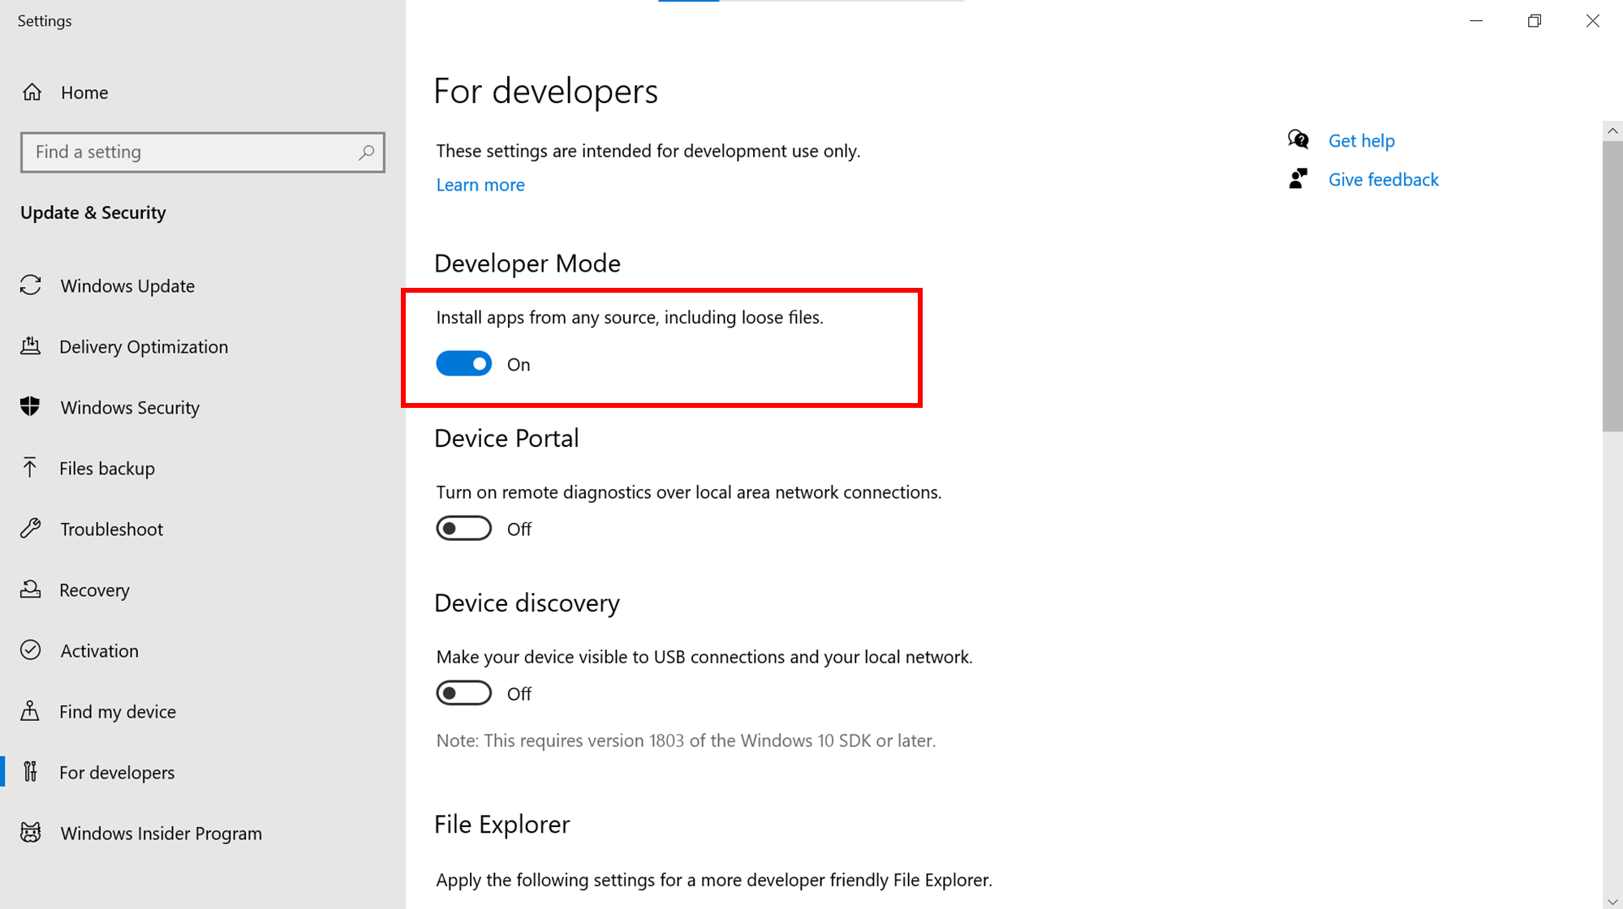

**Figure 3.26**:Enabling Developer Mode

1. Confirm to turn on the Developer Mode:

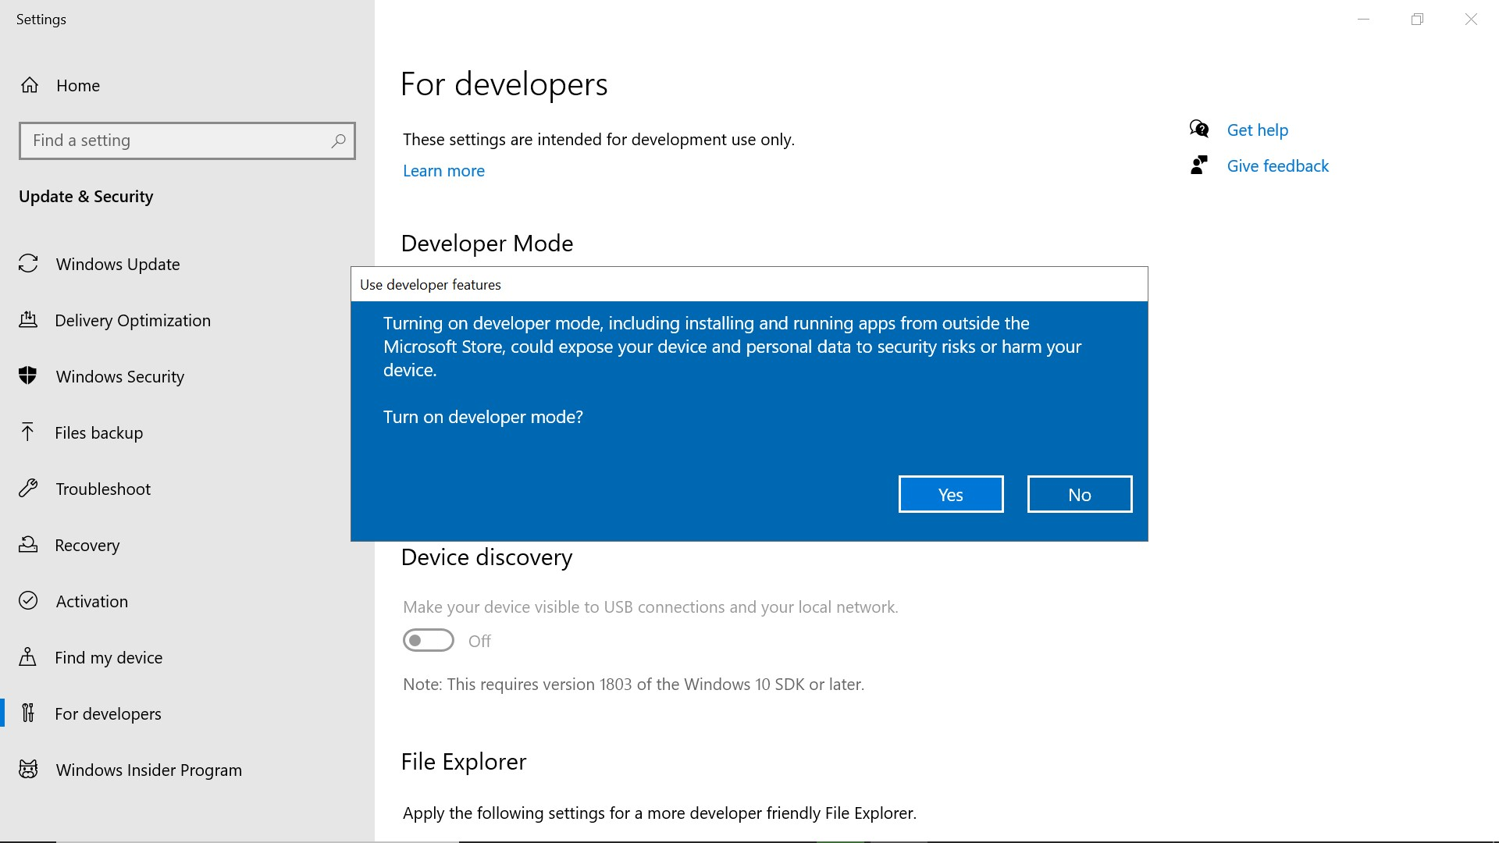

**Figure 3.26**:Confirmation to enable developer mode

1. Now, the application will be compiled, and you should be able to view the output of the default application created by Visual Studio:

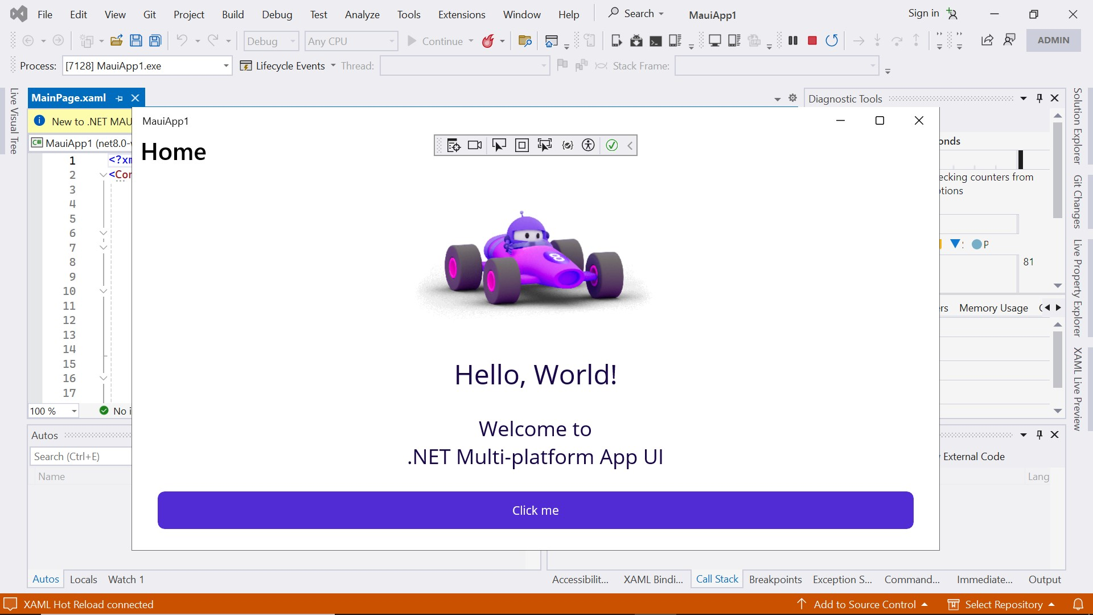

**Figure 3.27**: Output of .NET MAUI executing in Windows Machine

1. Click on the button a few times and observe that the click count is incremented in the button’s text:

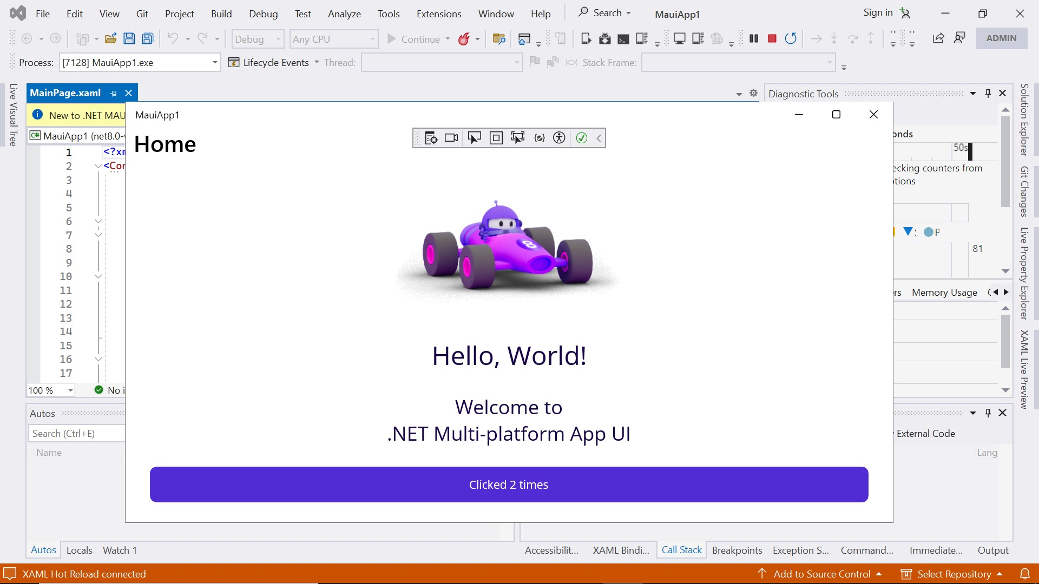

**Figure 3.28**:App in working state

Your PC is now enabled for developing and debugging on Windows.

Debugging on Android Emulator

Visual Studio lets you run the app in emulators that can simulate different Android devices. Follow these steps to debug on Android Emulator:

1. First, you need to create and configure the emulator. Go to **Tools…** **Android…** **Android Device Manager**:

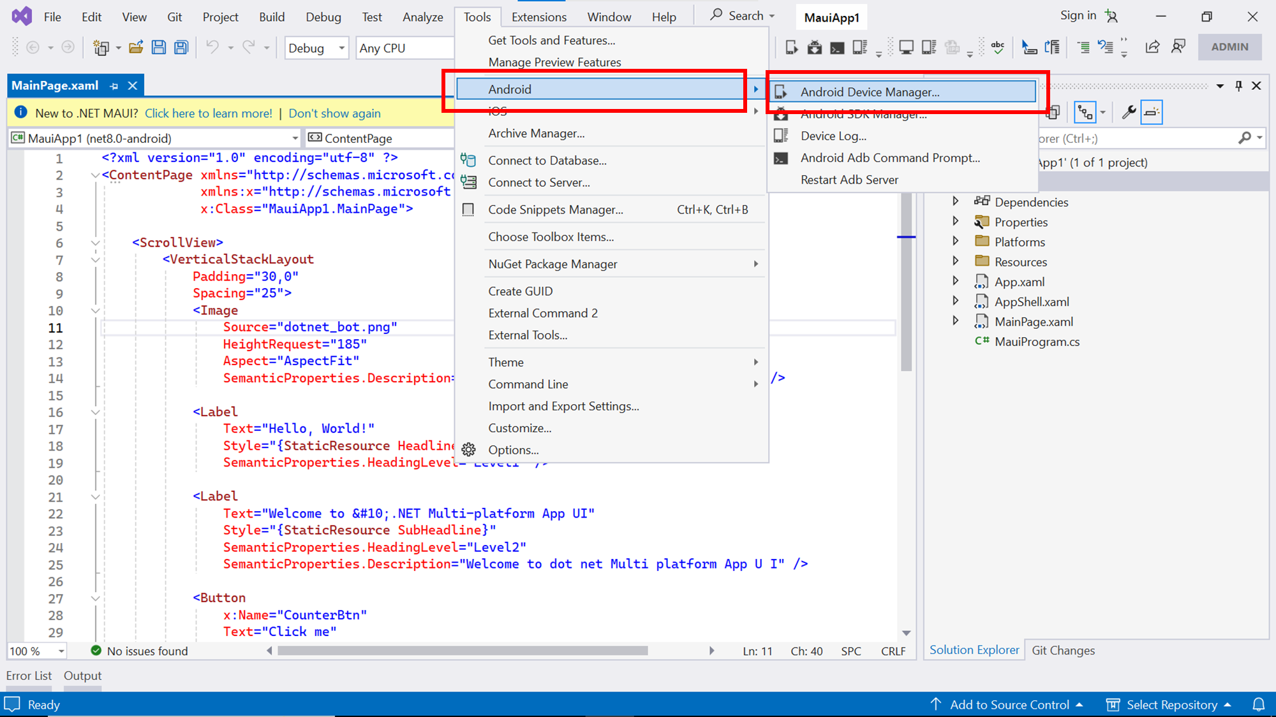

**Figure 3.29**: Selecting Android Device Manager

1. Initially, the **Android Device Manager** will be empty. You can add a new device by clicking on the **New** button:

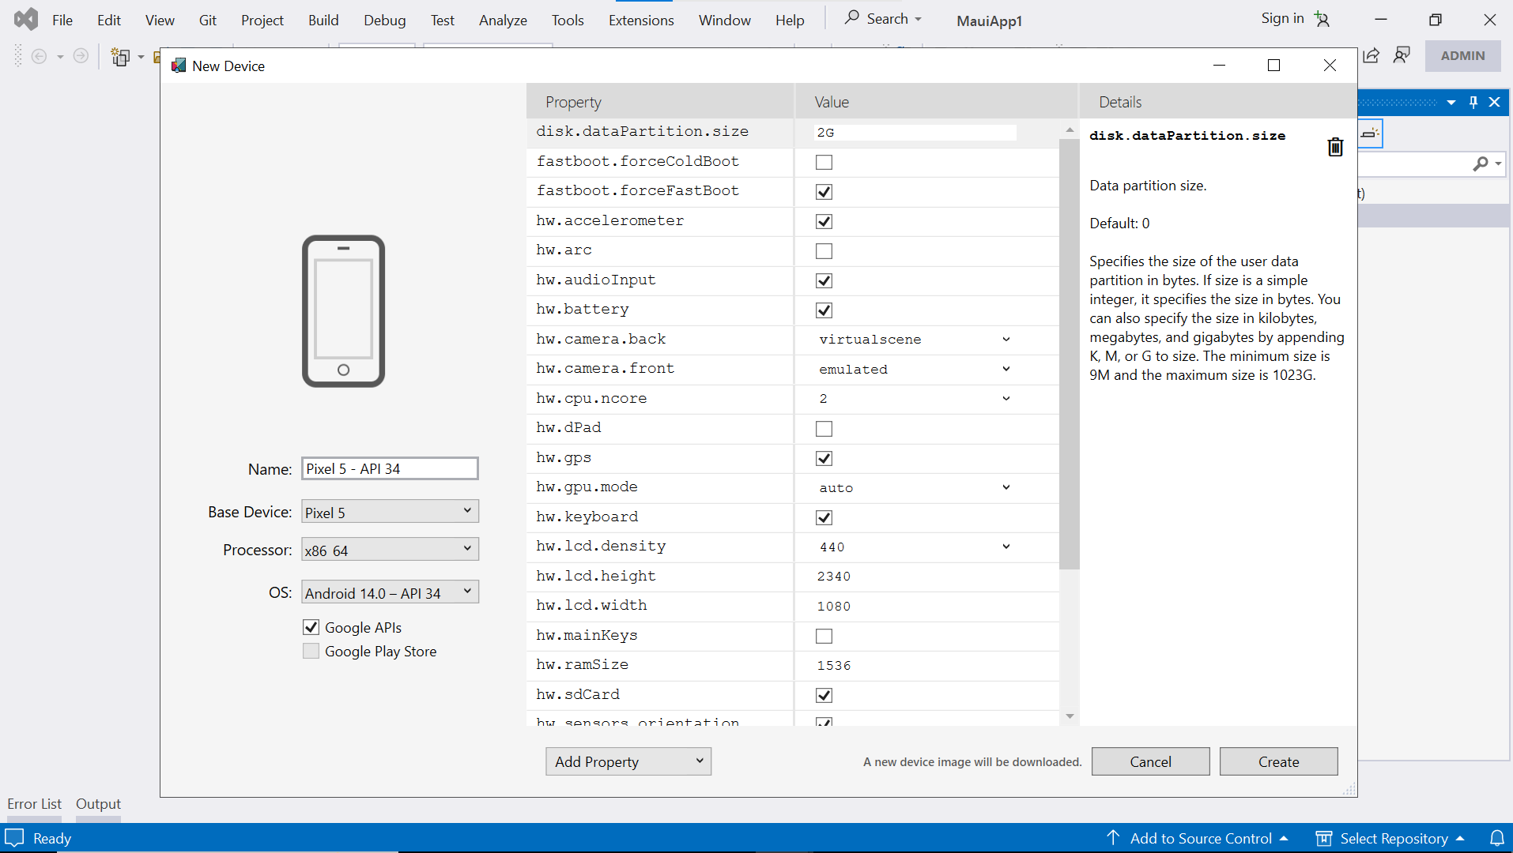

**Figure 3.30**:Adding a new device in Android Device Manager

1. You can leave the default options as it is and click on **Create**:
2. Accept the license terms that are displayed.

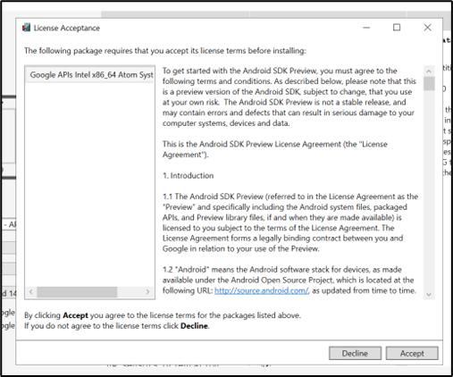

**Figure 3.31**:License Agreement for installing Android virtual device

1. Visual Studio will then download the device image and install it. After this process is completed, you should be able to see the virtual device listed in the Device Manager:

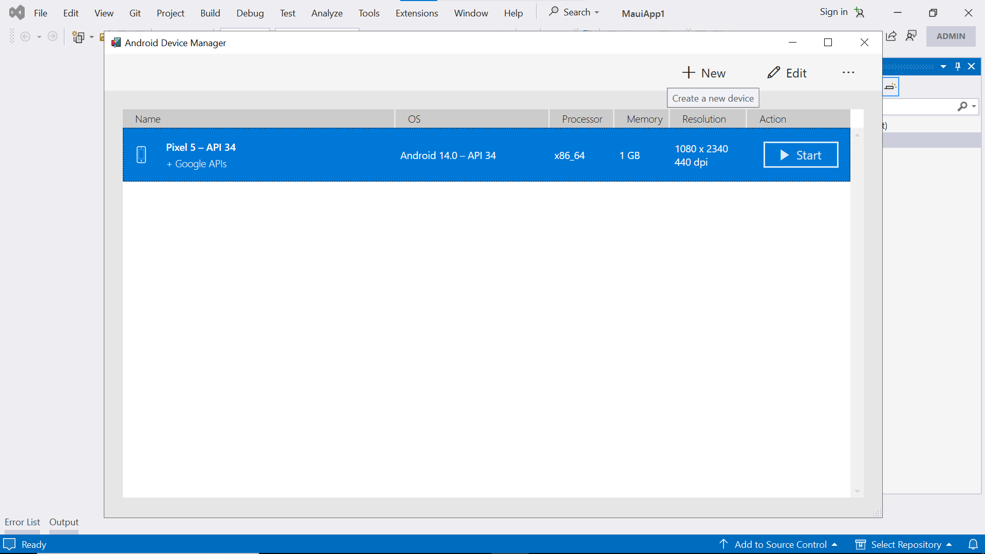

**Figure 3.32**: Virtual device installed

1. The virtual device will now be visible to select in the drop-down list to select the target for debugging:

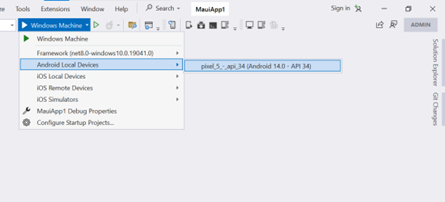

**Figure 3.33**: Selecting the Android Virtual Device for debugging

1. Select the virtual device and click on the **Play** button.
2. The emulator will start and if the code is compiled without any errors, the app will be launched inside the emulator.

Debugging on Android devices

While the Android Emulator is useful for testing your app quickly, it is important to also test it on a real Android device. To do this, you will need to turn on *Developer Mode* on your device and connect it to your computer.

To enable developer mode, follow these steps:

1. Go to the **Settings** screen.
2. Select **About phone***.*
3. Tap on **Build Number** seven times until you see the message **You are now a developer!**

Refer to the following figure:

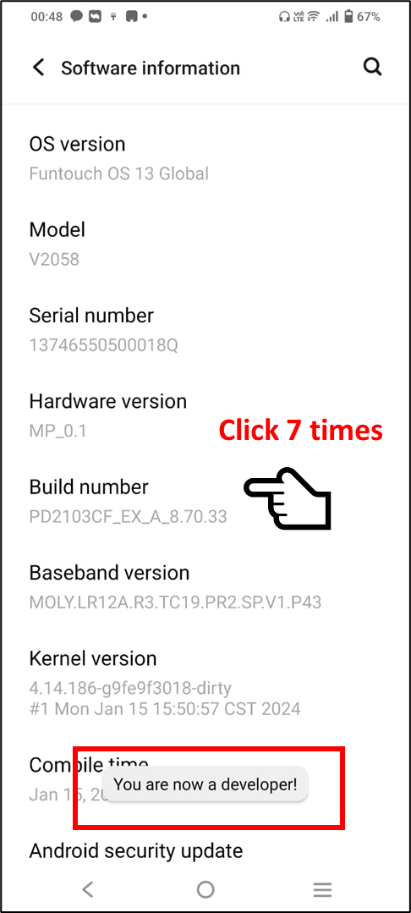

**Figure 3.34**: Turning on Developer Mode on Android device

Once Developer Mode is enabled, you need to turn on USB debugging:

1. Go to the **Settings** screen.
2. Select **Developer options***.*
3. Turn on the **USB debugging** option.

Refer to the following figure:

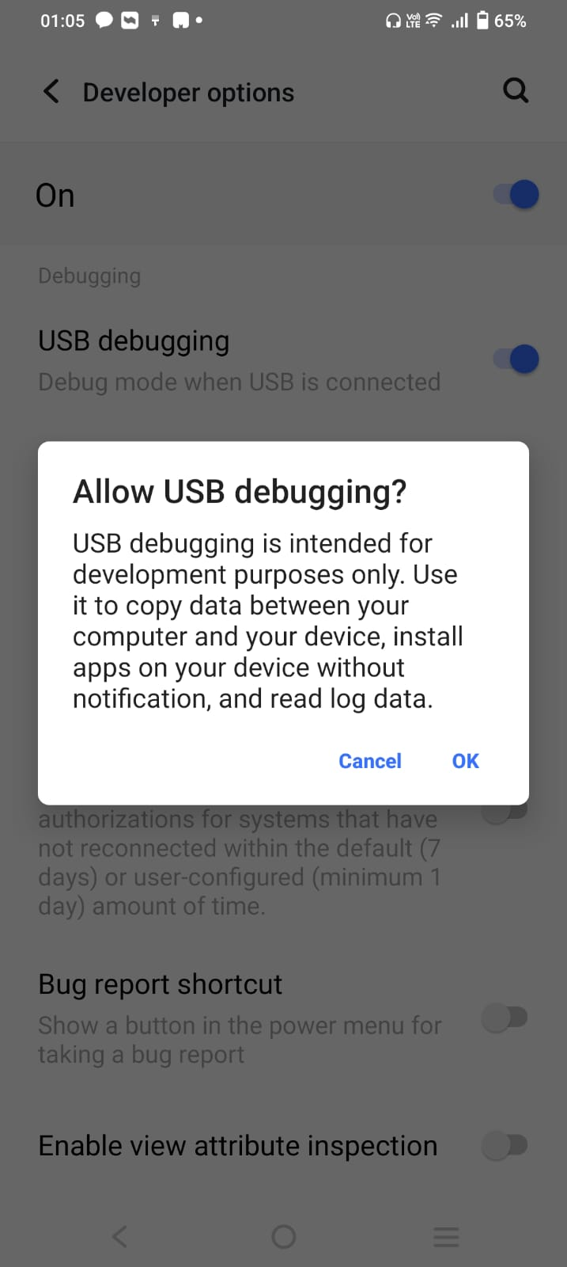

**Figure 3.35**: Allow USB debugging

1. Now, connect your device to the computer using a USB cable. If it is your first time connecting for debugging, you will see a prompt on your device asking if you trust the computer.
2. Select the option to always trust this computer to avoid seeing the prompt again.
3. Once the device is connected, it will be visible for you to select in the drop-down list of target devices.
4. Select it and click the **Play** button to execute the app on your device.

The procedure explained here is good for side-loading onto a device for testing purposes.

For distributing the app to a large number of users, it is recommended to create a Developer account in Android Play Store and publish the app to the Play Store. The procedure is outside the scope of this book.

iOS device provisioning

As already mentioned at the beginning of this chapter, we will discuss setting up the development environment in Windows PC. If you have a Mac and are developing on a Mac for the iPhone, you can follow the instructions given here.

When developing a .NET MAUI app for iOS on a Mac, you will need to install the .NET runtime and the latest version of Xcode from the App Store. Once this is done, you can execute simple commands in the Terminal to build and deploy the app to a device or to a simulator.

To test it on an iOS simulator, you must provide its **unique device ID** (**UDID**) in the command while building the app in the Terminal. The UDID will be available from within the **Simulators** tab in the Xcode setting for Devices and Simulators.

To test it on a real iOS device, you need to follow some steps, which are referred to as device provisioning. Firstly, you need to have an active subscription to Apple’s Developer Program—which may be either the regular one for individuals or the Enterprise program meant for organizations. Developers need to create a certificate, register the device they are using for development, and create an App ID and a provisioning profile.

When you deploy the app to a device, a provisioning profile is also installed on the device. This profile checks if the app was signed correctly and if it is allowed to run on that device. It checks things like the certificate used to sign the app, the App ID and if the device is registered in the provisioning profile.

Pair to Mac for iOS development

In case you prefer to use Windows to develop iOS apps, it is possible to do so if you can connect to a Mac in the same network as Apple’s Build tools run only on a Mac. Visual Studio provided a Pair to Mac feature using which you can discover, connect to and authenticate your Mac build host. With this approach, multiple users can connect to the same Mac simultaneously.

The steps to be followed to establish the pairing are demonstrated in the following figures:

1. On your Mac, invoke Spotlight by pressing *Cmd + Space*, and search for **Remote Login** and open the **Sharing System Preferences** window:

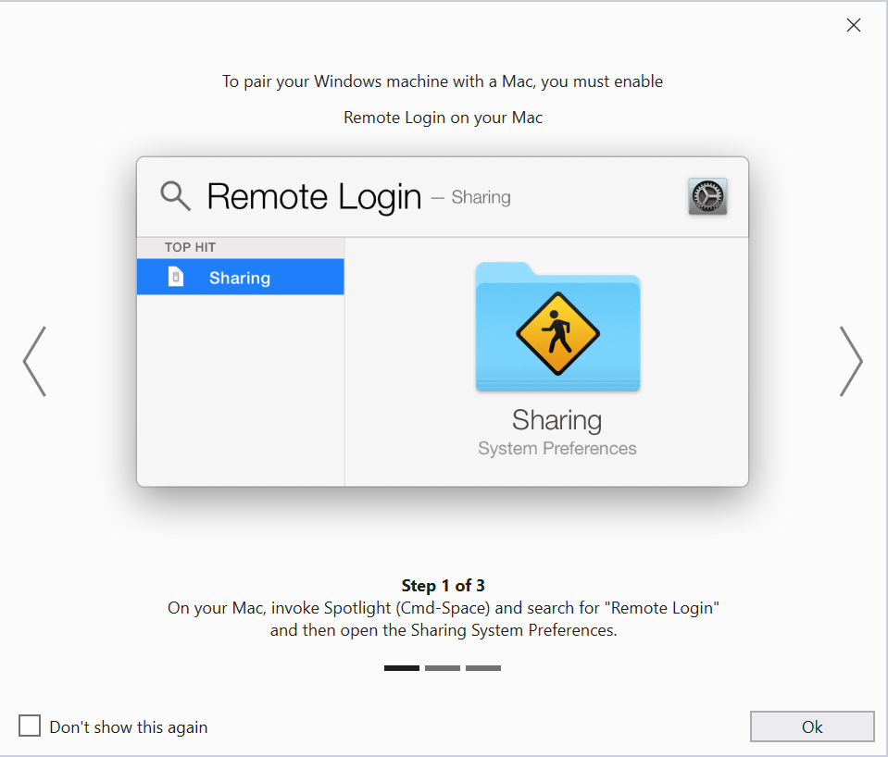

**Figure 3.36**:Accessing Sharing System Preferences

1. Enable the **Remote Login** option in the Sharing System Preferences window:

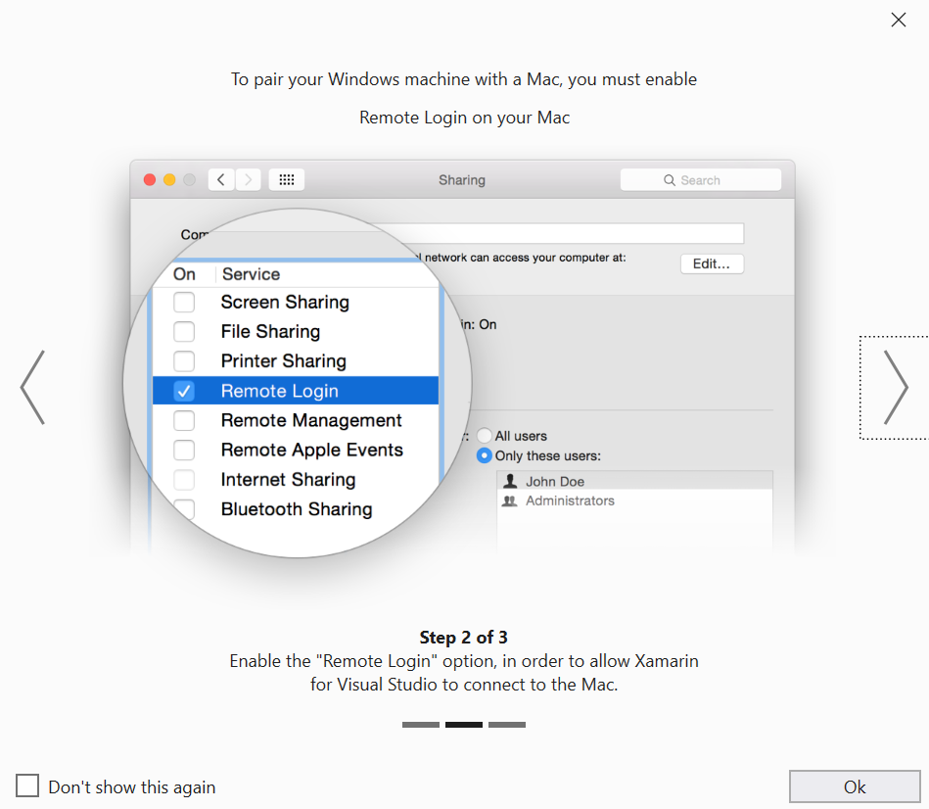

**Figure 3.37**: Remote Login option in Sharing System Preferences

1. Set access for **Only these users** and add your username in the list so that you can access the Mac through Remote Desktop:

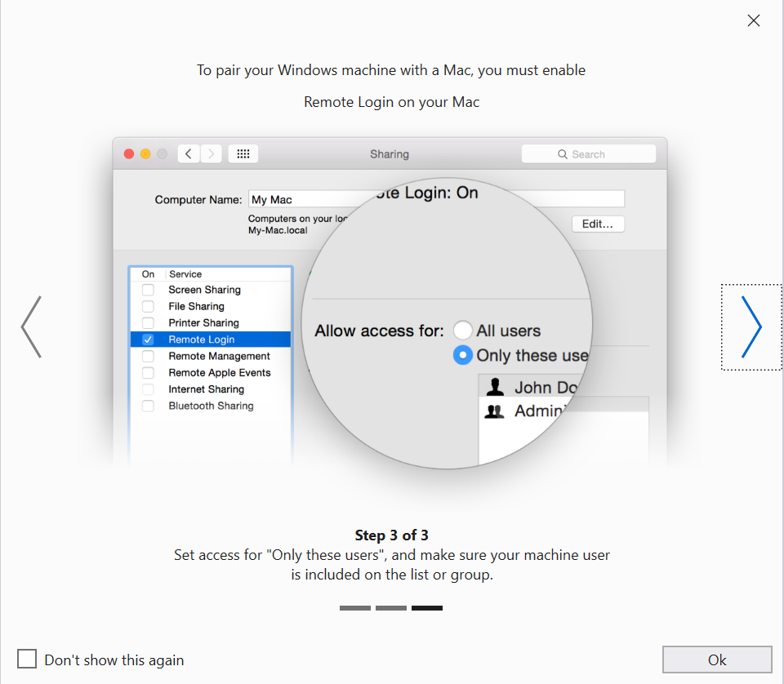

**Figure 3.38**: Enabling Remote Login

If you have successfully paired your Visual Studio environment to a Mac build host, you can test your app in an iOS simulator running on your Windows PC.

Conclusion

In this chapter, you have learned how to set up your development environment to build .NET MAUI apps. We also discussed how you can run your apps in multiple environments, including Windows, Android, and iOS. In the next chapter, we will look into C#, the programming language that will be used for the app development, that will equip you with the essential knowledge needed for the content in the upcoming chapters of the book.

Points to remember

Here are some key takeaways from this chapter:

* Install Visual Studio 2022 Community Edition.
* Enable Developer Mode in your Windows PC to test your apps in Windows.
* Install and configure Android emulator to test your apps in Android Virtual device.
* You can also enable developer mode in the Android device and run the app in your device.
* Testing apps on iOS requires you to have a Mac.
* You can develop on Windows if you can pair a Mac build host to your Visual Studio environment.
* Distribution of apps requires you to have a Windows Marketplace, Play Store or App Store account.